**Project Design Phase-I**

**Solution Architecture**

|  |  |
| --- | --- |
| Date | 19 September 2022 |
| Team ID | PNT2022TMID17878 |
| Project Name | Exploratory Analysis Of Rainfall Data In India For Agriculture |
| Maximum Marks | 4 Marks |

**Solution Architecture:**

Solution architecture is a complex process – with many sub-processes – that bridges the gap between business problems and technology solutions. Its goals are to:

* Find the best tech solution to solve existing business problems.
* Describe the structure, characteristics, behavior, and other aspects of the software to project stakeholders.
* Define features, development phases, and solution requirements.
* Provide specifications according to which the solution is defined, managed, and delivered.

**Example - Solution Architecture Diagram:**

Indian weather data from1998-2015

 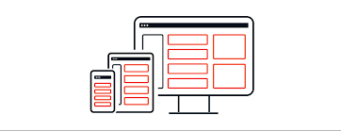  

Evaluation

Send data to backend for processing

Farmer enquires by entering “region name”

ML model

Output as “Rainfall predicted in mm” and “crops to grow” in that season

Predicted Output

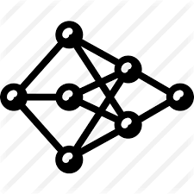

Algorithm

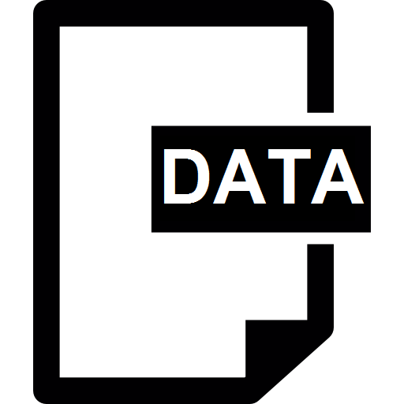

Training data